* **Use CSS Background Properties To Design Given Layouts**

1)

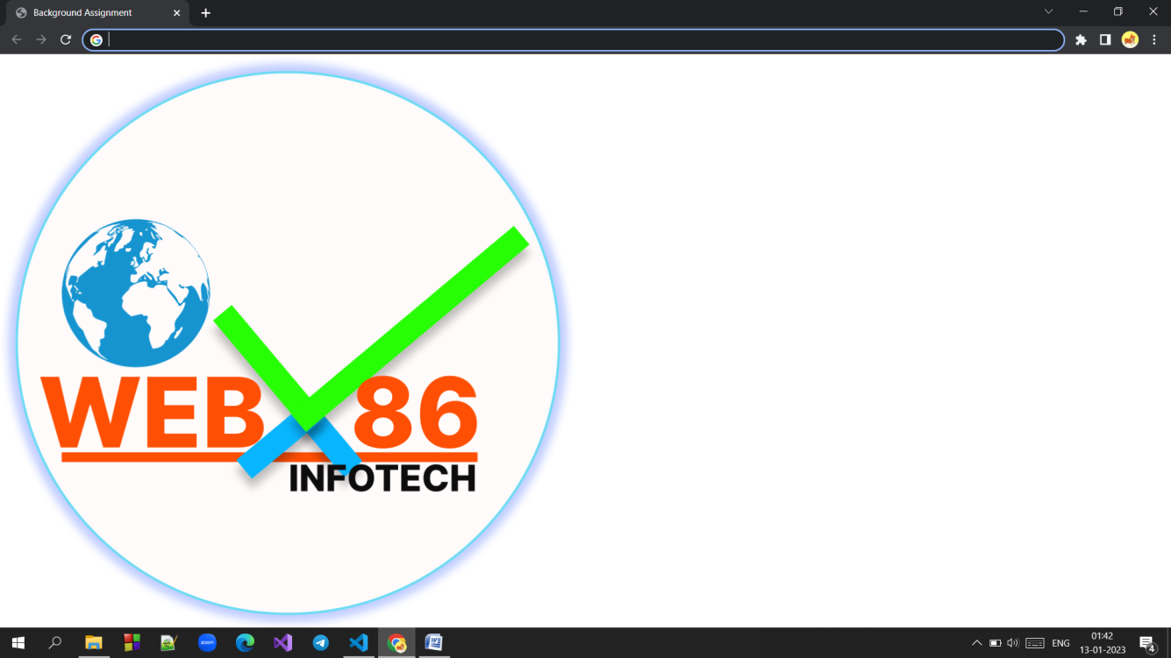

2)

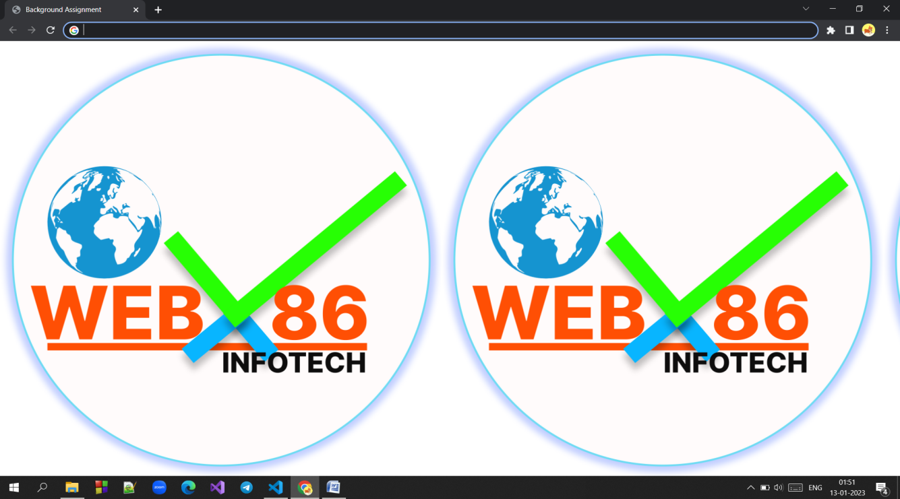

3)

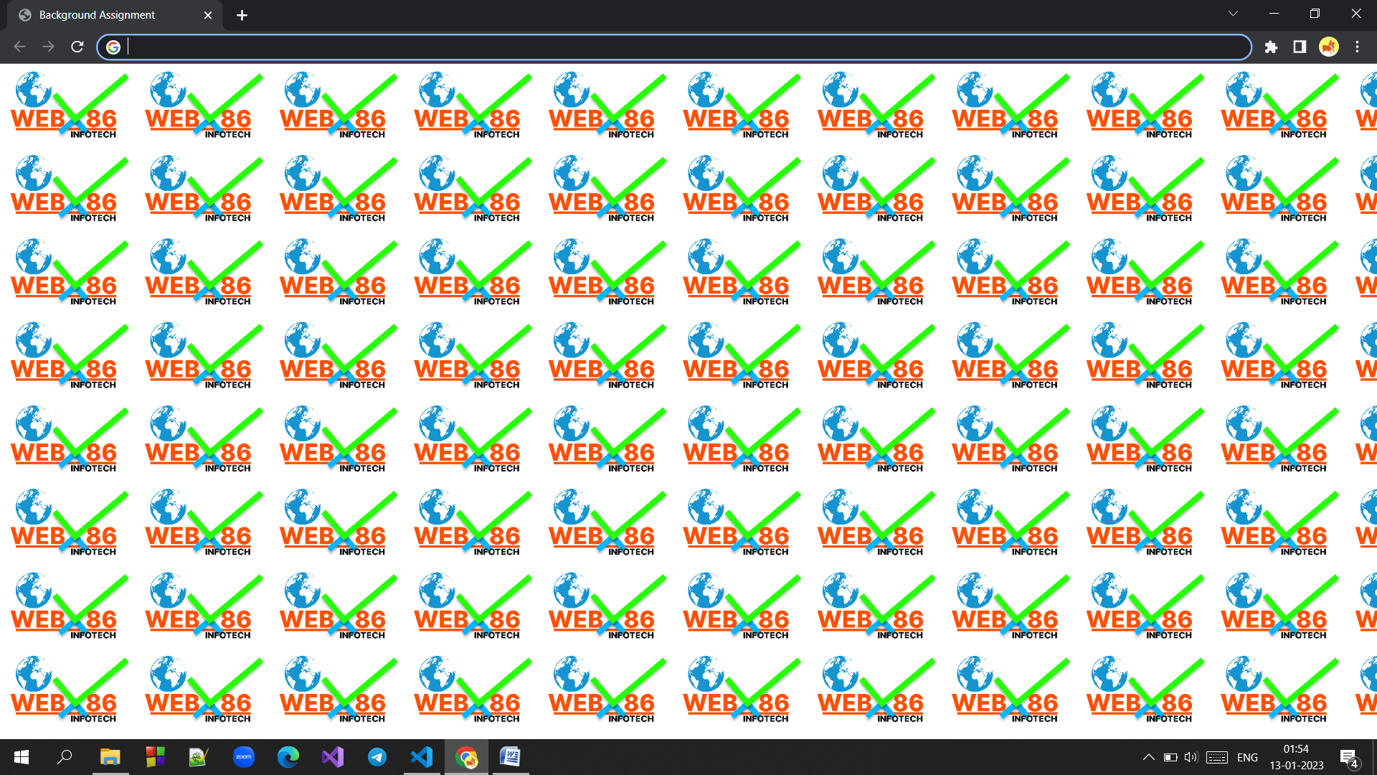

4)

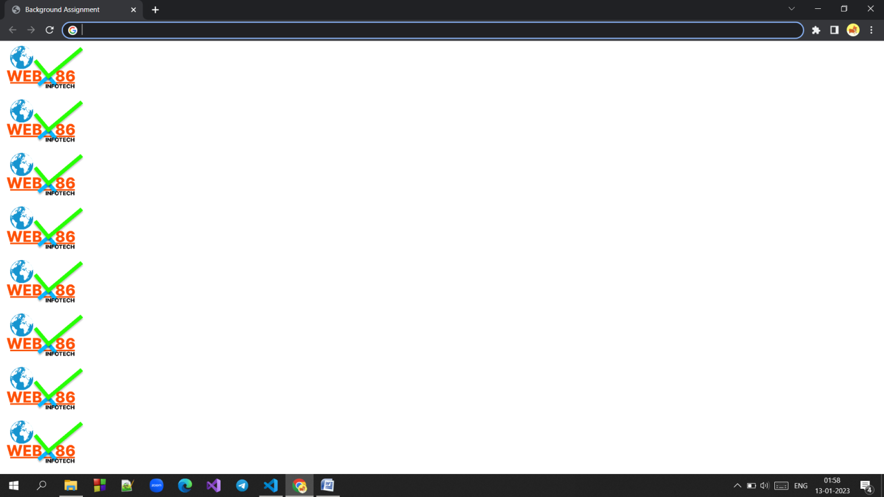

5)

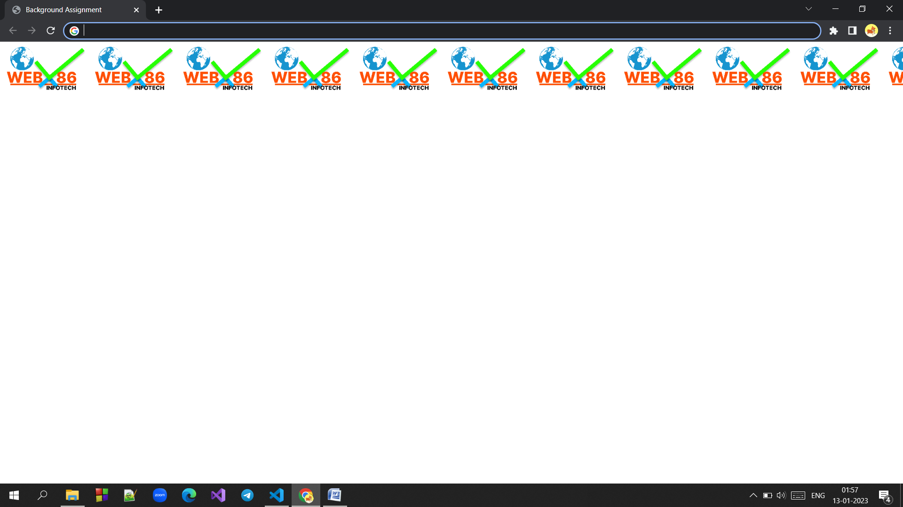

6) For Below Layout:

Image Size Is 250px and the Colour of the page is Aqua

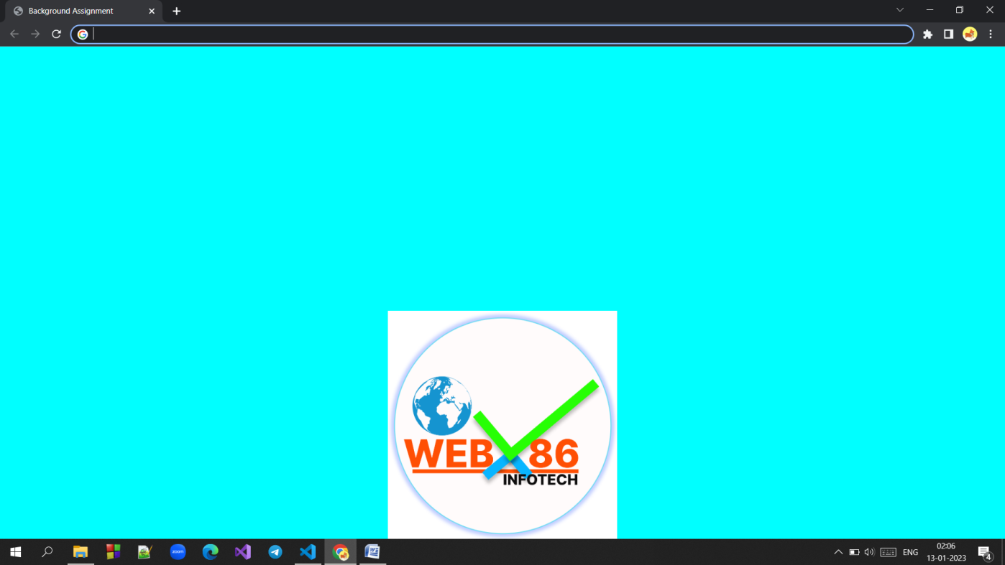

Note :

* We have provided the images used in this assignment on our official group.
* Use CSS background properties to complete this assignment.